**Database management systems**

# **PLSQL Labsheet – 2**

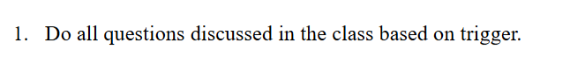

1. **Update the emp_no by incrementing it every time an employee joins.**

-- Step 1: Create Tables

CREATE TABLE Dept (

Dno INT PRIMARY KEY,

Dname VARCHAR(50),

Emp_count INT DEFAULT 0

);

CREATE TABLE Emp (

Eno INT PRIMARY KEY,

Ename VARCHAR(50),

Sal NUMERIC(10, 2),

Dno INT REFERENCES Dept(Dno)

);

-- Step 2: Function to Increment Employee Count on Insert

CREATE FUNCTION update_count() RETURNS TRIGGER AS

$$

BEGIN

UPDATE Dept

SET Emp_count = Emp_count + 1

WHERE Dno = NEW.Dno;

RETURN NEW;

END;

$$

LANGUAGE 'plpgsql';

-- Step 3: Trigger to Call update_count Function on Insert

CREATE TRIGGER emp_update

AFTER INSERT ON Emp

FOR EACH ROW

EXECUTE FUNCTION update_count();

-- Step 4: Insert Departments

INSERT INTO Dept (Dno, Dname) VALUES

(1, 'HR'),

(2, 'IT'),

(3, 'Finance');

-- Step 5: Insert Employees

INSERT INTO Emp (Eno, Ename, Sal, Dno) VALUES

(101, 'Alice', 50000, 1),

(102, 'Bob', 60000, 2),

(103, 'Charlie', 55000, 3);

-- Step 6: Verify Results

SELECT * FROM Dept;

SELECT * FROM Emp;

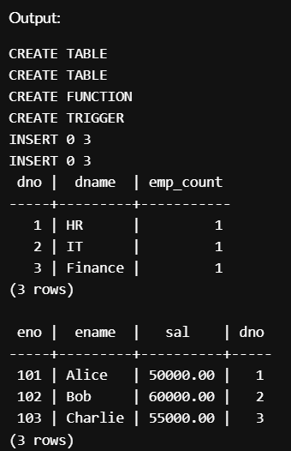

1. **Consider the following Emp table; whenever the salary column to any employee an audit to that change must be automatically need to be added to the sal_audit table.**

CREATE TABLE Emp (

eno INT PRIMARY KEY,

name TEXT,

sal NUMERIC

);

CREATE TABLE sal_audit (

eno INT,

old_sal NUMERIC,

new_sal NUMERIC,

modified_by TEXT,

modified_at TIMESTAMP

);

CREATE FUNCTION update_sal_audit()

RETURNS TRIGGER AS

$$

BEGIN

-- Insert the old and new salary information into the sal_audit table

INSERT INTO sal_audit (eno, old_sal, new_sal, modified_by, modified_at)

VALUES (OLD.eno, OLD.sal, NEW.sal, USER, now());

-- Return the NEW row to allow the update to proceed

RETURN NEW;

END;

$$

LANGUAGE plpgsql;

CREATE TRIGGER sal_audit_trigger

AFTER UPDATE OF sal ON Emp

FOR EACH ROW

EXECUTE FUNCTION update_sal_audit();

--example

INSERT INTO Emp (eno, name, sal) VALUES (1, 'Alice', 50000);

UPDATE Emp SET sal = 55000 WHERE eno = 1;

SELECT * FROM sal_audit;

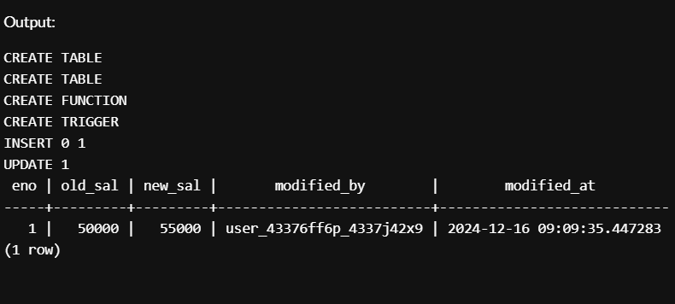



CREATE TABLE Emp (

eno INT,

name TEXT,

sal NUMERIC

);

CREATE FUNCTION data_validate()

RETURNS TRIGGER AS

$$

BEGIN

-- Validate that 'eno' is not NULL

IF NEW.eno IS NULL THEN

RAISE EXCEPTION 'Employee number (eno) cannot be NULL';

END IF;

-- Validate that 'sal' is greater than 0

IF NEW.sal <= 0 THEN

RAISE EXCEPTION 'Salary must be greater than 0';

END IF;

-- Return the NEW row to proceed with the operation

RETURN NEW;

END;

$$

LANGUAGE plpgsql;

CREATE TRIGGER validate_emp_data

BEFORE INSERT OR UPDATE ON Emp

FOR EACH ROW

EXECUTE FUNCTION data_validate();

INSERT INTO Emp (eno, name, sal) VALUES (1, 'Alice', 50000); -- Succeeds

INSERT INTO Emp (eno, name, sal) VALUES (NULL, 'Bob', 30000); -- Fails with "Employee number (eno) cannot be NULL"

INSERT INTO Emp (eno, name, sal) VALUES (2, 'Charlie', -5000); -- Fails with "Salary must be greater than 0"

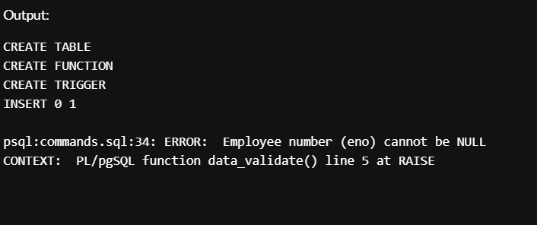





**-- Create Emp table**

**CREATE TABLE Emp (**

**emp_id INT PRIMARY KEY,**

**emp_name VARCHAR(100),**

**salary DECIMAL**

**);**

**-- Insert sample data**

**INSERT INTO Emp (emp_id, emp_name, salary)**

**VALUES (1, 'John Doe', 50000),**

**(2, 'Jane Smith', 60000),**

**(3, 'Alice Johnson', 70000);**

**CREATE OR REPLACE FUNCTION check_postgres_user()**

**RETURNS TRIGGER AS $$**

**BEGIN**

**-- Check if the user is 'postgres'**

**IF current_user <> 'postgres' THEN**

**RAISE EXCEPTION 'Only the postgres user can modify the salary column';**

**END IF;**

**RETURN NEW;**

**END;**

**$$ LANGUAGE plpgsql;**

**CREATE TRIGGER salary_update_trigger**

**BEFORE UPDATE OF salary ON Emp**

**FOR EACH ROW**

**EXECUTE FUNCTION check_postgres_user();**

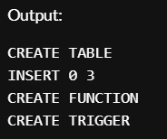

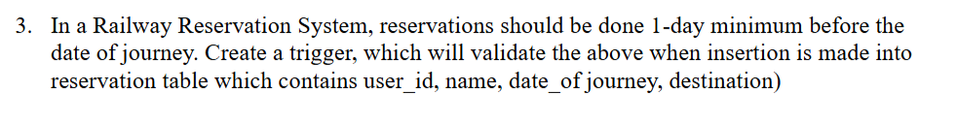

**-- Create reservation table**

**CREATE TABLE reservation (**

**user_id INT,**

**name VARCHAR(100),**

**date_of_journey DATE,**

**destination VARCHAR(100),**

**PRIMARY KEY (user_id, date_of_journey)**

**);**

**-- Insert sample data**

**INSERT INTO reservation (user_id, name, date_of_journey, destination)**

**VALUES (1, 'John Doe', '2024-12-17', 'Paris'),**

**(2, 'Alice Smith', '2024-12-19', 'London'),**

**(3, 'Bob Brown', '2024-12-16', 'New York'); -- This should raise an exception in the trigger**

**-- Create trigger function to validate reservation date**

**CREATE OR REPLACE FUNCTION validate_reservation_date()**

**RETURNS TRIGGER AS $$**

**BEGIN**

**IF NEW.date_of_journey < CURRENT_DATE + INTERVAL '1 day' THEN**

**RAISE EXCEPTION 'Reservations must be made at least one day in advance.';**

**END IF;**

**RETURN NEW;**

**END;**

**$$ LANGUAGE plpgsql;**

**-- Create trigger to apply the function on insert into reservation table**

**CREATE TRIGGER reservation_date_trigger**

**BEFORE INSERT ON reservation**

**FOR EACH ROW**

**EXECUTE FUNCTION validate_reservation_date();**

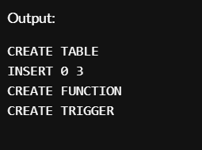

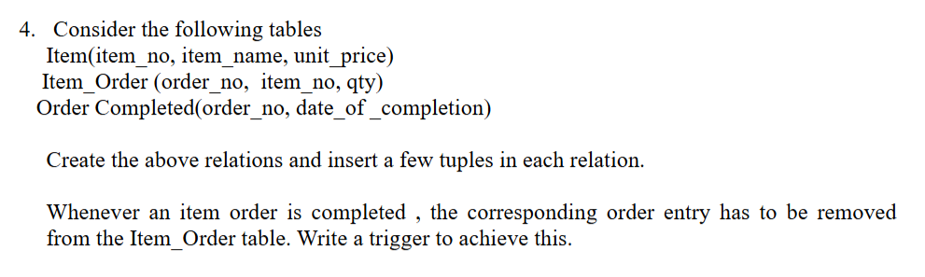

**-- Create Item table**

**CREATE TABLE Item (**

**item_no INT PRIMARY KEY,**

**item_name VARCHAR(100),**

**unit_price DECIMAL**

**);**

**-- Create Item_Order table**

**CREATE TABLE Item_Order (**

**order_no INT PRIMARY KEY,**

**item_no INT,**

**qty INT,**

**FOREIGN KEY (item_no) REFERENCES Item(item_no)**

**);**

**-- Create Order_Completed table**

**CREATE TABLE Order_Completed (**

**order_no INT,**

**date_of_completion DATE,**

**FOREIGN KEY (order_no) REFERENCES Item_Order(order_no)**

**);**

**-- Insert sample data into Item table**

**INSERT INTO Item (item_no, item_name, unit_price)**

**VALUES (1, 'Laptop', 1000),**

**(2, 'Phone', 500),**

**(3, 'Headphone', 100);**

**-- Insert sample data into Item_Order table**

**INSERT INTO Item_Order (order_no, item_no, qty)**

**VALUES (101, 1, 2),**

**(102, 2, 3);**

**-- Insert sample data into Order_Completed table**

**INSERT INTO Order_Completed (order_no, date_of_completion)**

**VALUES (101, '2024-12-15'),**

**(102, '2024-12-16');**

**-- Create trigger function to remove item order entry after completion**

**CREATE OR REPLACE FUNCTION remove_item_order()**

**RETURNS TRIGGER AS $$**

**BEGIN**

**DELETE FROM Item_Order WHERE order_no = NEW.order_no;**

**RETURN NEW;**

**END;**

**$$ LANGUAGE plpgsql;**

**-- Create trigger to apply the function on insert into Order_Completed**

**CREATE TRIGGER remove_item_order_trigger**

**AFTER INSERT ON Order_Completed**

**FOR EACH ROW**

**EXECUTE FUNCTION remove_item_order();**

